**Module :3- Linux server - Configure local storage Assignment**

**24. Different Filesystem Types**

ext4: Commonly used in Linux, supports large files and volumes, journaling.

NTFS: Used by Windows, supports large files, security features, journaling.

FAT32: Compatible with many OS, limited to 4GB file size, no journaling.

exFAT: Extended FAT, supports large files, used in flash drives.

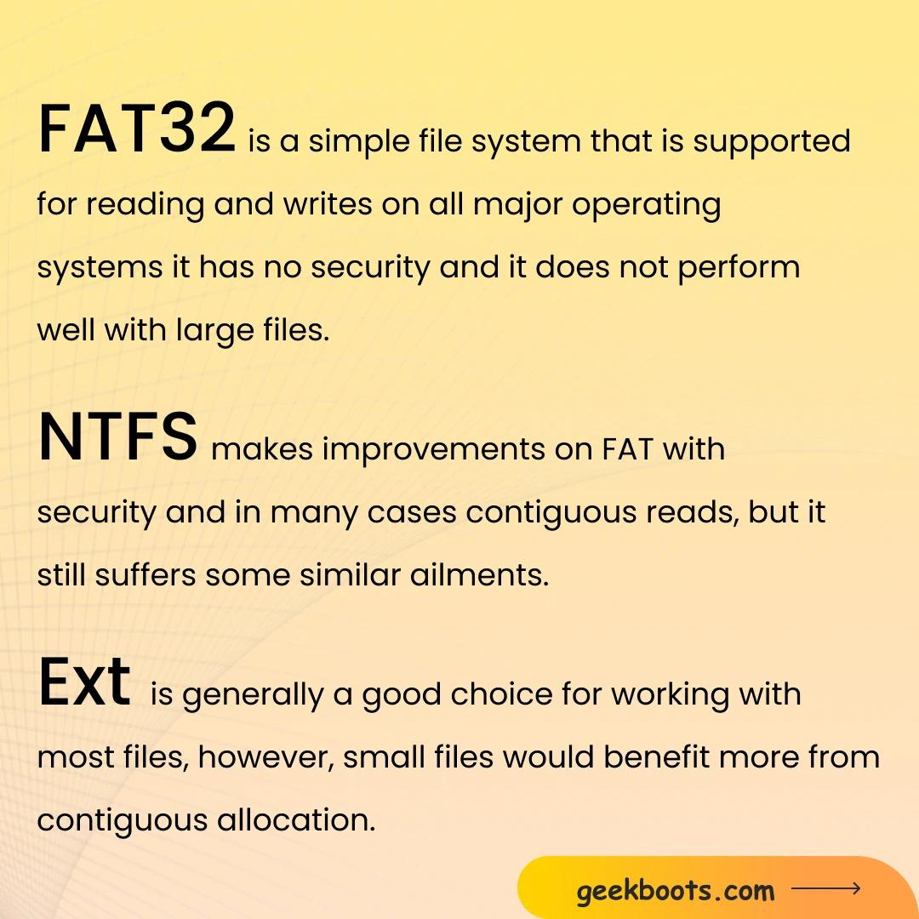

**25. Manage Disk Partitions and Filesystems**

List Partitions:

sudo fdisk -l

Create Partition:

sudo fdisk /dev/sdX

Follow prompts to create a new partition. As it show select partition as you want.

Format Partition:

sudo mkfs.ext4 /dev/sdX1

Mount Partition:

sudo mount /dev/sdX1 /mnt

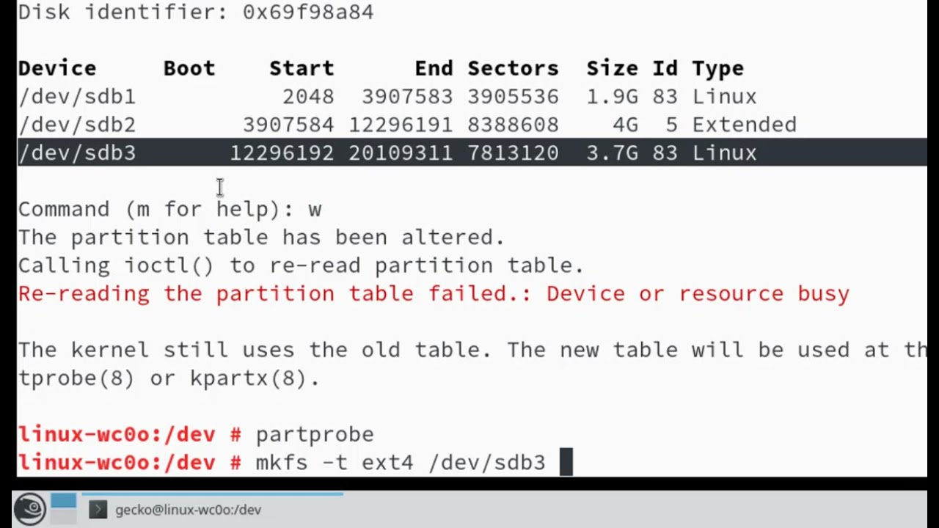

**26. Create a 2048MB Partition and Verify**

Open fdisk:

sudo fdisk /dev/sdX

Create New Partition:

Press n for new partition.

Select p for primary.

Specify partition size: +2048M.

Write Changes:

Press w to write changes.

Verify:

sudo fdisk -l /dev/sdX

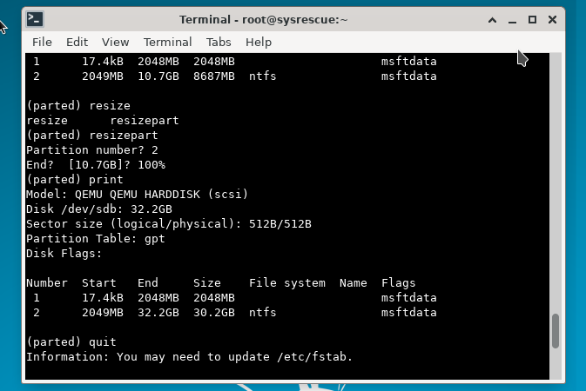

**27. Why LVM is Required**

LVM (Logical Volume Manager) allows for flexible disk management. It enables resizing, adding, and moving partitions without downtime, making it easier to manage storage1.

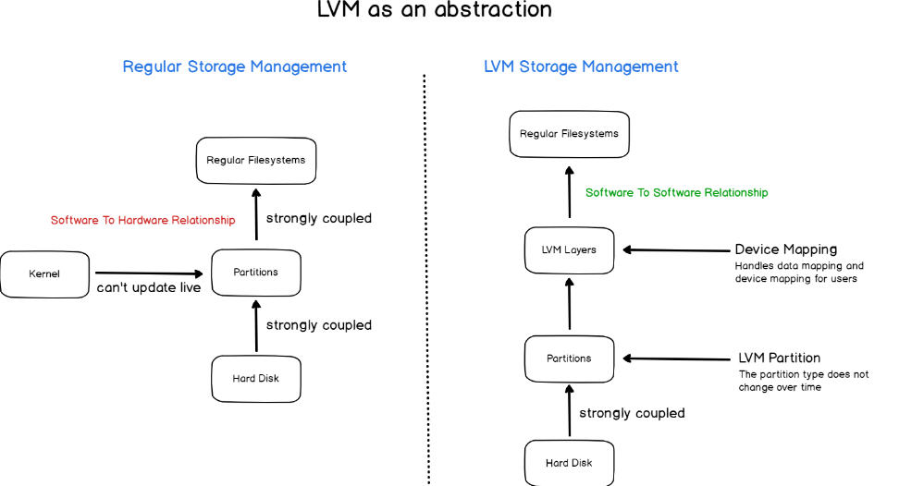

**28. Find Out How Much Memory Linux is Using**

Using free Command:

free -h

Using top Command:

top

Using htop Command (if installed):

htop